4 x 4 Low Telltale – CGEA1.3

Functional Description

The purpose of the 4 x 4 Low telltale is to inform the driver that the vehicle is operating in four wheel drive Low mode.

This STSS is to be used for a fixed LED telltale only. For a fixed / dedicated RTT use RTT STSS.

The 4x4 Low telltale correlates the AwdLoLamp_D_RqDsply signal originating from the TCCM, the module configuration, and the Operational Mode to illuminate or extinguish the 4x4 Low telltale. The 4x4 Low telltale shall provide an iconic representation that will illuminate or extinguish to inform the driver whether they are in 4x4 mode or some other mode.

Interfaces

Interface Context Diagram (I/O Block Diagram)
Figure 1 4x4 Low Indication Context Diagram
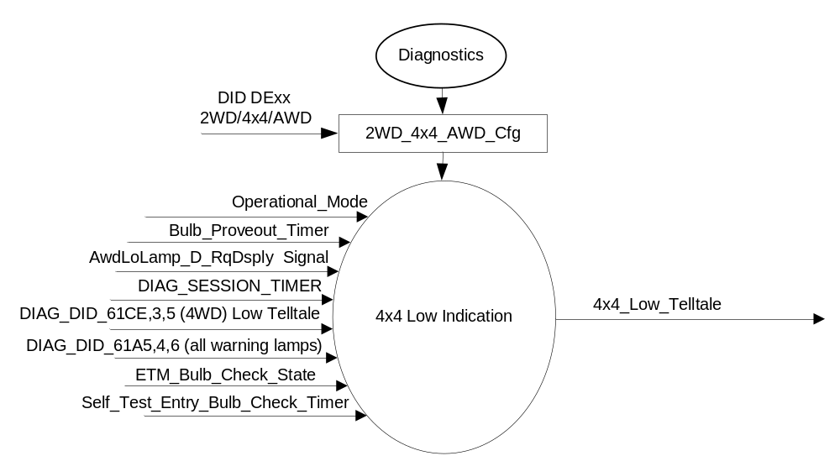

Inputs

      - INTERNAL:
            - DIAG_SESSION_TIMER
            - Operational_Mode
            - 2WD_4x4_AWD_Cfg
            - Bulb_Proveout_Timer
            - DIAG_DID_61CE,3,5 Four Wheel Drive (4WD) Low Telltale
            - DIAG_DID_61A5,4,6 (all warning lamps)
            - ETM_Bulb_Check_State
            - Self_Test_Entry_Bulb_Check_Timer
      - MUX message on the CAN Bus

- Signal AwdLoLamp_D_RqDsply
ID | Size  (bits) | Detail | Units | Res. | Offset | State Encoded | Min. | Max.
AwdLoLamp_D_RqDsply | 2 |  | SED | 1 | 0 |  | 0(0x0) | 0 3 (0x3)
 |  | Off |  |  |  | 0x0
 |  | On |  |  |  | 0x1
 |  | Flash |  |  |  | 0x2
 |  | Not_Used |  |  |  | 0x3

Outputs
- 4x4_Low_Telltale, which is used to control the state of the LED.

Function/Performance

Operational Modes

Mode | Differentiating Vehicle Conditions
Sleep Mode | 4x4 Low Telltale OFF
Limited Mode | 4x4 Low Telltale OFF
Normal Mode | 4x4 Low Telltale ON/OFF
Crank Mode | 4x4 Low Telltale ON/OFF

Voltage Levels

Refer to the Cluster Features table located in the Operational Modes and Voltage Range Strategies section in this SPSS

Human-Machine Interface

Visual

Indicator Graphics / Display Format
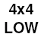

For actual symbol definition refer to database # 1.914 of the 03-0685 ARL requirement.

Indicator Color Coordinates

Amber - Reference SDS IL-0017/IS-0379

Indicator Characteristics

LED - 4x4 Low Telltale

Audio

None.

System Accuracy

The 4x4_Low_Telltale shall change the state of the Telltale within 100msec of a state change as indicated in the state matrix reference 1.3.5.1 Subsystem Algorithm Flowchart / State Diagram.

Operation: Performance and Functional

Subsystem Algorithm Flowchart / State Diagram

Figure 1.1 4 x 4 Low Telltale Diagnostic Configuration Flowchart

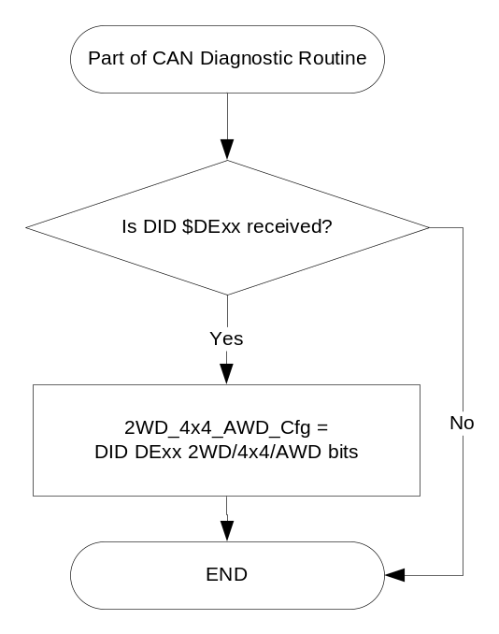

- State Matrix for 4X4_LOW_Telltale
2WD_ 4x4_ AWD_ Cfg | Operational_ mode | ETM Bulb_ Check_State | DIAG_ SESSION_ TIMER | Self_Test_ Entry_Bulb_ Check_Timer | DIAG_DID_61CE,3,5  Four Wheel Drive (4WD) Low Telltale | DIAG_DID_61A5,4,6  (all warning lamps) | Bulb_ Proveout_ Timer | AwdLoLamp_ D_RqDsply | 4x4_Low_  Telltale
4x4 | Normal or Crank | X | Not Active | X | X | X | Active | X | ON
4x4 | Normal or Crank | X | Not Active | X | X | X | X | ON (0x1) | ON
4x4 | Normal or Crank | ON (0x1) | Not Active | X | X | X | X | X | ON
4x4 | Normal | X | Active | Not Active | Not Received | Not Received | Active | X | ON
4x4 | Normal | X | Active | Not Active | Not Received | Not Received | X | ON (0x1) | ON
4x4 | Normal | ON (0x1) | Active | Not Active | Not Received | Not Received | X | X | ON
4x4 | Normal | X | Active | X | ON (0x1) | X | X | X | ON
4x4 | Normal | X | Active | X | X | ON (0x1) | X | X | ON
4x4 | Normal | X | Active | Active | X | X | X | X | ON
All other cases |  |  |  |  |  |  |  |  | Off
X=Don’t Care
Not Received = The state when a DIAG_SESSION_TIMER is active and the DID has not been received

Operation Description (supports algorithm flowchart /state diagram)

Function Safety Classification (EMC)

Class B

Memory Storage
Parameter Name | Description | Value at  Battery Connect | Value at  Module Wake-up
2WD_4x4_AWD_Cfg | State indicator for feature presence controlled via CAN at AOL at VO plant | Use Stored Value | Use Stored Value
4x4_Low_Telltale | Used to control the state of the LED | Off (0x0) | Off (0x0)
AwdLoLamp_ D_RqDsply signal | CAN signal sent from 4x4CM. | Off (0x0) | Off (0x0)
DIAG_DID_61CE, 3, 5  [(4WD) Low Telltale] | Warning Lamp "B" Status byte 3 bit 5  Four Wheel Drive (4WD) Low Telltale | Off (0x0) | Off (0x0)
DIAG_DID_61A5,4,6 (all warning lamps) | Indicator Lamp Control 2, byte 2, bit 6 (all warning lamps) | Off (0x0) | Off (0x0)
ETM_Bulb_Check_State | State indictator for warning bulb in ETM | OFF (0x0) | OFF (0x0)
Operational_Mode | 4 state indicator for cluster operational mode | Limited | Limited, Normal or Crank

Parameter Name | Description | Value at  Battery Connect | Value at  Module Wake-up
DIAG_SESSION_TIMER | Timer used to time-out a diagnostic session | Not Active | Not Active
Bulb_Proveout_Timer | Internal command directing prove out | Not Active | Not Active
Self_Test_Entry_Bulb_Check_ Timer | Timer used in diagnostic session to do a self check of telltales | Not Active | Not Active

Prove Out

3.0 +/- 0.1 seconds as per bulb prove out section. Cluster controls prove out. No DTCs shall be logged while in Prove Out.

Reconfigurable Telltale

No.

Message Center Msg

None

Error Handling

Missing Message Strategy

The signals will be declared missing as per the Diagnostics section of this SPSS.

DTCs states and history will be determined as per the Diagnostics section of this SPSS.
If the 2WD_4x4_AWD configuration is not 4x4 (01), the cluster shall never log a missing message DTC due to this feature.

Diagnostics

Self Test

Bulb illuminated during self test as per Self_Entry_Bulb_Check_Timer

Engineering Test Mode

Reference section “Dealer / Engineering Test Mode (ETM)”.

Part II Performance

DIDs
Number | PID / CommonID Name | PID Type
61CE,3,5 | Warning Lamp "B" Status byte 3 bit 5  Four Wheel Drive (4WD) Low Telltale | Bit Mapped
61A5,4,6 | Indicator Lamp Control 2, byte 4, bit 6 (all warning lamps) | Bit Mapped

Supported Diagnostic Trouble Codes (DTCs)
DTCs shall be logged as per the diagnostic section of this SPSS.

DTC | Description
C10200 | Lost Communication with Transfer Case Control Module

DID $DExx
Block  Num | Block Description | Size (bits) |  | Byte(s) | Bits | State: Description | "0" | "1" | Default | Comments/  Information
PACKETED BLOCKS
xx | Option Content (B&A) |  |  | * | 2 | 2WD/4x4/AWD | encoded | encoded | 01 - 4x4
 |  |  |  |  |  | 00 - 2WD | encoded | encoded
 |  |  |  |  |  | 01 - 4x4 | encoded | encoded
 |  |  |  |  |  | 10 - AWD | encoded | encoded
 |  |  |  |  |  | 11 – Not Used | encoded | encoded
*Byte and bit location to be identified in Part II Specification for this cluster

Reference Specification

FO-0007 FOUR WHEEL DRIVE MODE DISPLAY
FO-0008 FOUR WHEEL DRIVE FAULT INDICATOR

IS-0001 WARNINGS/INDICATORS/DISPLAYS PROVEOUT
IS-0046 INSTRUMENTATION MATERIAL RESISTANCE TO CLEANING
IS-0052 OPERATING VOLTAGES - FUNCTIONAL/PERFORMANCE
IS-0069 FUNCTIONAL IMPORTANCE CLASS
IS-0324 WINDSHIELD & OTHER REFLECTIONS
IS-0327 WARNING INDICATOR EVALUATION
IS-0329 FLICKERING OF LAMPS
IS-0379 NORTH AMERICAN WARNINGS AND INDICATORS STRATEGY

IL-0017 TELLTALE AND INTERIOR ILLUMINATION COLOR
IL-0021 CRAFTSMANSHIP - DISPLAYS
IL-0023 CLARITY/LEGIBILITY/READABILITY
IL-0025 INTERIOR ILLUMINATION INTENSITY
IL -0027 VISUAL CONTRAST
IL -0043 OPERATIONAL ENVIRONMENT FUNCTIONALITY
IL -0045 COLOR
IL -0047 TELLTALE; INDICATOR AND DISPLAY LIGHT INTENSITY
IL -0048 ILLUMINATION ACCEPTABILITY

03-0661 PLACEMENT: CONTROL AND DISPLAY LOCATIONS
03-0662 PLACEMENT: LOGICAL GROUPING FUNCTION AND USAGE
03-0664 PLACEMENT: DOWN VISION TO COMPONENTS WITH HIGH VISUAL DEMAND
03-0665 PLACEMENT: EXPECTED LOCATIONS OF CONTROLS AND DISPLAYS VDS
03-0670 INTERIOR VISIBILITY
03-0671 INTERIOR VISIBILITY: REFLECTIONS FROM COMPONENTS & SURFACES
03-0672 INTERIOR VISIBILITY: REFLECTIONS IN DISPLAYS
03-0673 INTERIOR VISIBILITY: VISUAL OBSCURATIONS
03-0674 INTERIOR VISIBILITY: ILLUMINATION CONTROLS / DISPLAYS
03-0675 INTERIOR VISIBILITY: VEILING GLARE
03-0677 INTERIOR VISIBILITY: SUNLIGHT WASHOUT
03-0681 IDENTIFICATION: CHARACTER AND SYMBOL SIZE
03-0682 IDENTIFICATION: LEGIBILITY
03-0685 IDENTIFICATION: SYMBOLS, ABBREV FOR CONTROL
03-0721 LOGIC OF OPERATION: OPERATIONAL STEREOTYPES
03-0722 LOGIC OF OPERATION: INTERPRETATION
03-0723 LOGIC OF OPERATION: USE OF SYSTEMS WITH VISUAL DISPLAYS

Revision History

SPSS Module Revision History

Revision Level | Name | Change Description | Date
1.0 | V. Patel | Updated for CGEA 1.3 based on CGEA STSS v1.0  Section 1.2.2 – Deleted table referencing the HS-CAN message that contains the input signal. Deleted “POS” column from table 1.0  Section 1.4 – Rewritten. Removed references of specific missing message flags.  Section 1.5.3 – DTC logging criteria from the table. | 3/25/2010
1.1 | J.Blatchford | Intent of this change is to change 4x4 Diagnostic DID from TBD to that as released.  - 1.1: Changed usage to LED telltale applications only.  - Updated TBD DID to DIAG_DID_61CE,3,6 Four Wheel Drive (4WD) High Telltale throughout document. | 11/01/12
1.2 | S. Watkins  M. Hakim | Update for DE00 to DExx, as well as adding configuration new value and default. Also general cleanup.  Section 1.1: Identified the source module from where the signal AwdLowLamp_D_RqDsply originated.  Sections 1.2.1, 1.3.5.1, and 1.5.3:  Updated the configuration DID number from “00” to “xx” to accommodate the extended number of configuration DIDs.  Section 1.2.2: Removed specifying which CAN bus and module name.  Section 1.3.5.1:  - Added Figure 1.1 Title.  - Switched order of the first two columns of Table 1.1  Section 1.3.5.4:  - Added 2WD_4x4_AWD_Cfg to Memory Storage table.  - Added identification of (4WD) Low Telltale DID to Parameter Name.  Section 1.5.3: For configuration DID, added State Description “11 – Not Used” and “01” for Default.  Updated document footer. | 8/21/2013

